7.77: Let 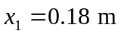, 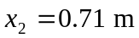. The spring constants (assumed identical) are then known in terms of the unknown weight w, 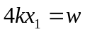. The speed of the brother at a given height h above the point of maximum compression is then found from
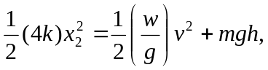

or
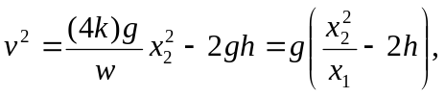
so , or 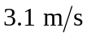 to two figures. b) Setting 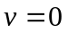 and solving for h,
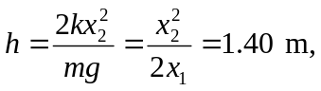
or 1.4 m to two figures. c) No; the distance  will be different, and the ratio 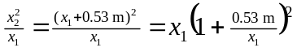 will be different. Note that on a small planet, with lower g, will be smaller and h will be larger.

